15、Ultrasonic obstacle avoidance with Servo pan

**Follow the steps to splice the building blocks ：**

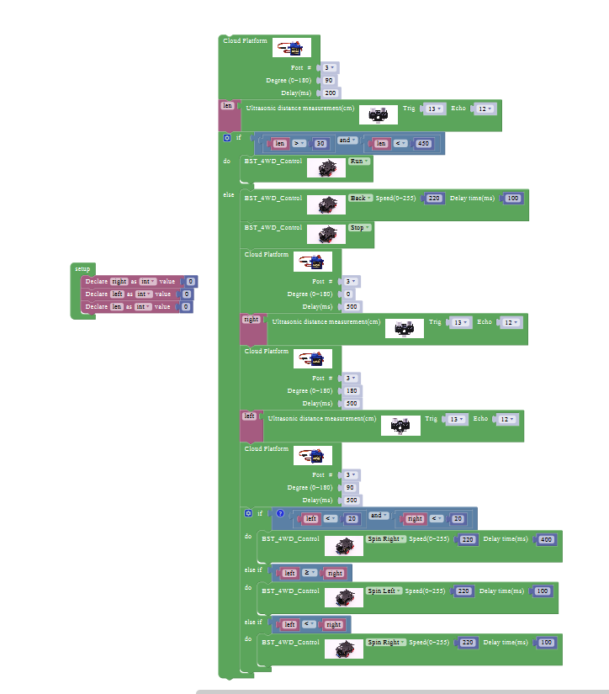

**1、Experimental building blocks :**

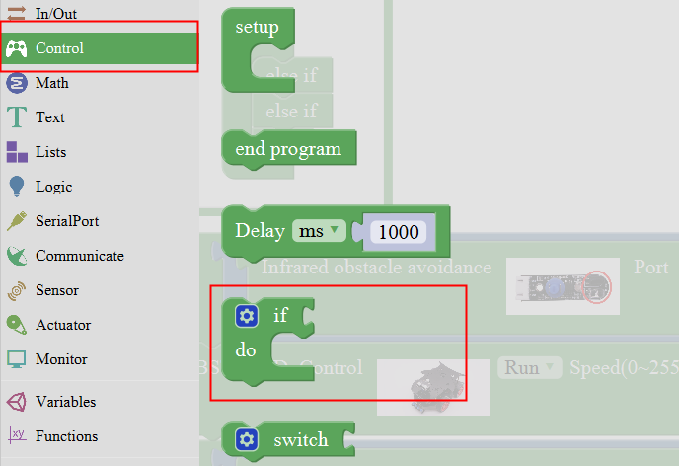

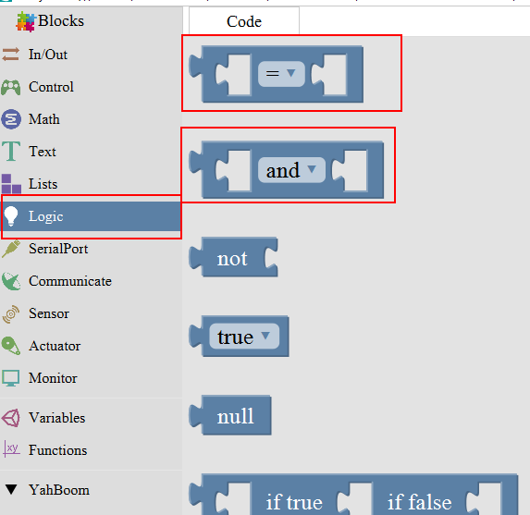

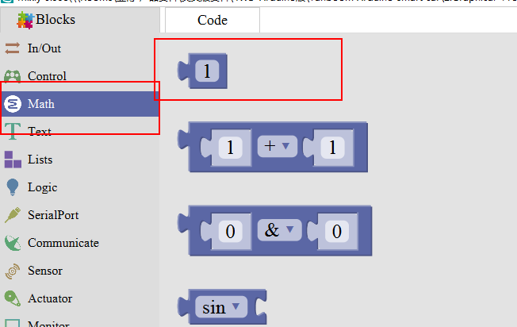

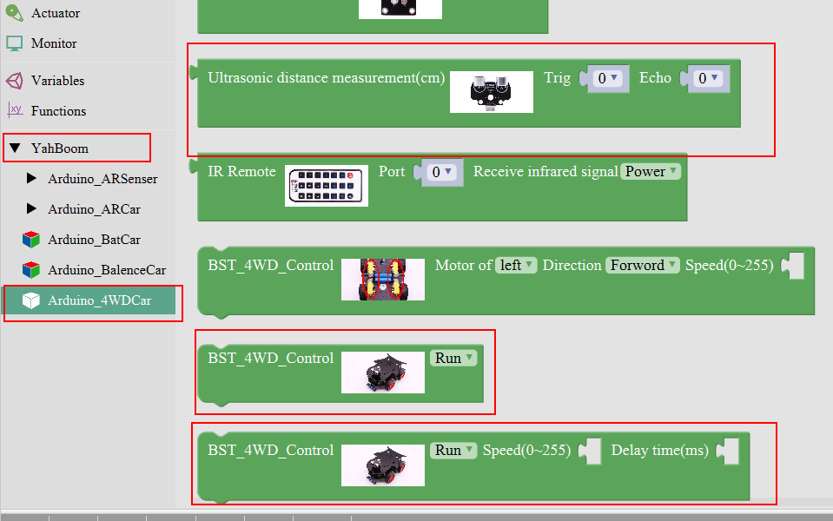

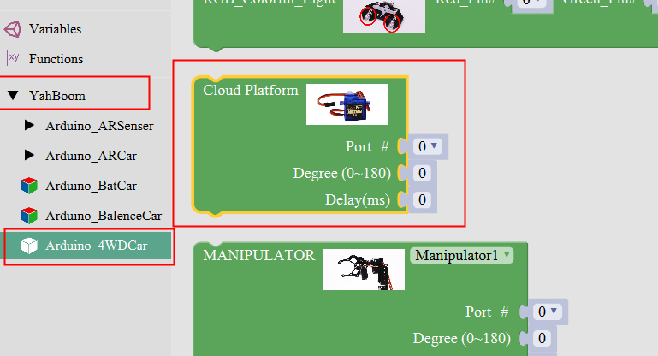

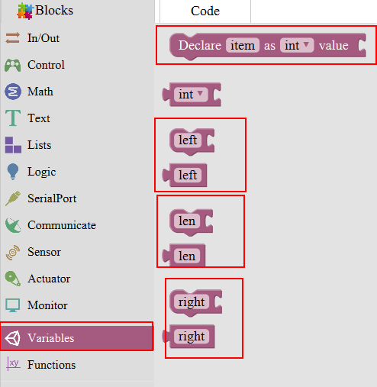

**2、Experimental verification：**

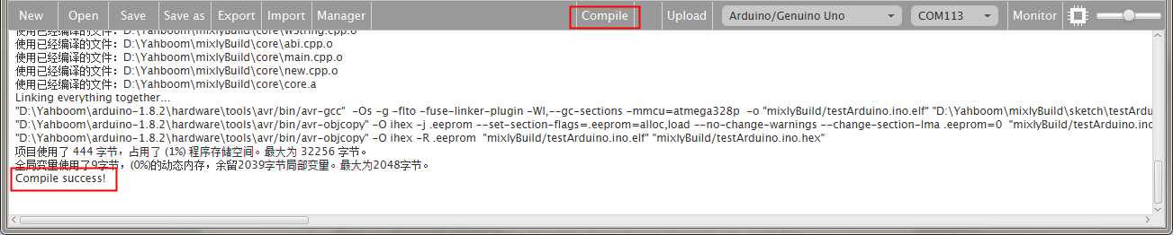

a、After splicing, select the compile button above the picture, wait for the completion of the compiler, the following box will prompt the compiler successfully, if prompt the compile failure is the problem of building block splicing.

b、After compiled , select **Arduino/Genuino Uno** follow the picture,

selects the serial number of the corresponding board.

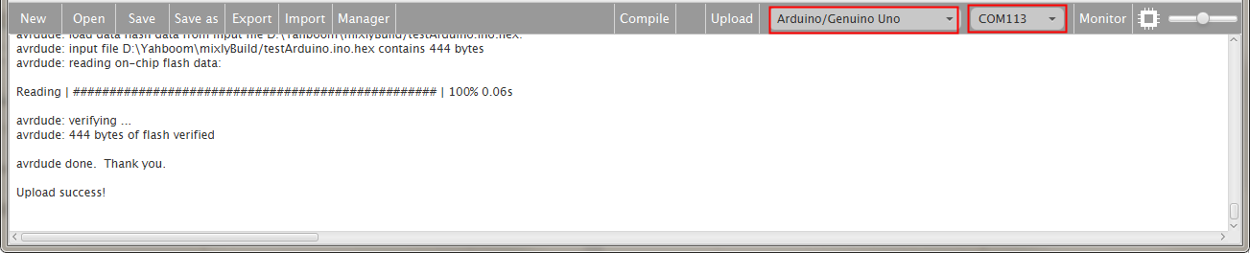

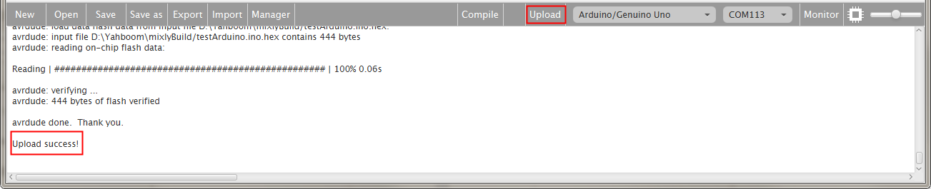

C、After configured,select the upload button above the picture, wait for the following box prompt the upload successfully.The car is placed in the obstacle avoidance area, turn on the power, the car forward, obstacle distance is greater than 30 and less than 450 straight, stop the car less than or equal to 30, and the left rudder left shaking measuring distance, measuring roll right right distance judgments about distance, about less than 20 turn, the left and right distance who is to either side, continue to repeat the obstacle avoidance.